Employee Attrition Logistic Regression Report

Executive Summary
The logistic regression model was developed to identify key drivers of employee attrition. The model achieved an overall accuracy of 0.8120, indicating strong predictive performance. Findings highlight that employee satisfaction, workload, tenure, and compensation are the most significant factors influencing attrition risk.

Model Performance
Accuracy: 0.8120
Class 0 (Stayed): Precision = 0.9300, Recall = 0.8200, F1 = 0.8700
Class 1 (Left): Precision = 0.5700, Recall = 0.7900, F1 = 0.6700
Confusion Matrix:
[[1876, 418]
[146, 560]]
The model performs very well at identifying employees who stay, while still capturing a strong proportion of employees who leave.

Key Drivers of Attrition
Employees with low satisfaction are the strongest drivers of attrition (coefficient = 1.1793). High workload (0.3871) and mid-tenure employees (3–5 years: 0.3818) also significantly increase attrition risk. Additional contributors include tenure, time spent at company, and lower salary levels.

Factors Driving Retention
Work accidents (-0.5072) and number of projects (-0.4170) are associated with lower attrition. Higher salaries (-0.3730) and longer tenure bands also reduce attrition likelihood. Promotions (-0.1536) significantly improve retention outcomes.

Top Drivers Visualization
The chart below illustrates the most important features influencing attrition:
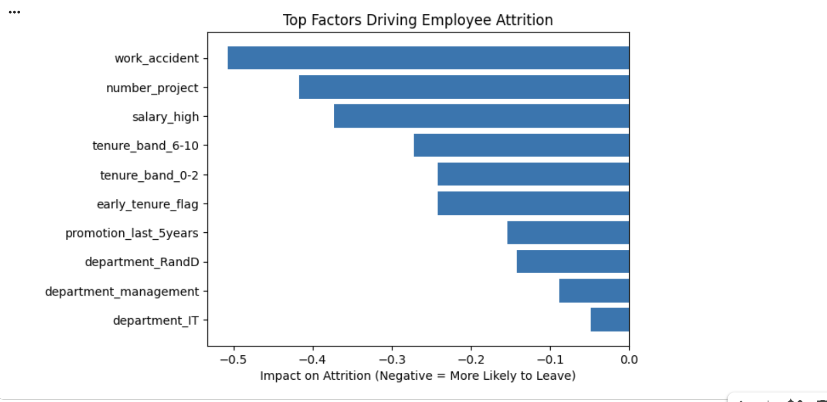

Recommendations
1. Focus on improving employee satisfaction through engagement initiatives.
2. Monitor workload to prevent burnout.
3. Prioritize retention strategies for employees in the 3–5 year tenure range.
4. Implement structured promotion pathways.
5. Review compensation strategies for at-risk employees.

